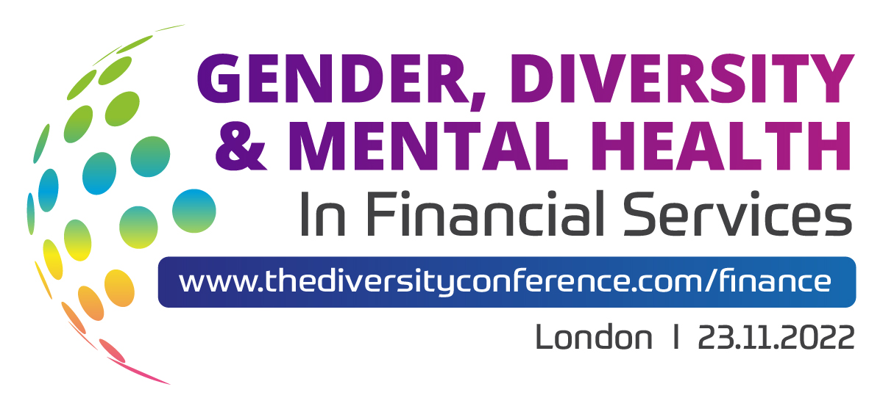

Welcome to The Gender, Diversity & Mental Health In Financial Services Conference!

Official Programme

Please note that these timings are flexible. Due to the nature of a live event, the conference chairs and organisers will be updating the timings throughout the day to adapt to speakers running over time, late arrivals, last minute changes and extending popular sessions. Please rest assured we will do our utmost to adapt and to accommodate all live changes.

Registration, Informal Networking & GIC Welcome
08.30 – 09.00

Morning Chair’s Opening Remarks
09.00 – 09.15
Iain Brumpton
Head of People Commercials & Performance
Zurich UK

Gender: Women In Finance – Panel Discussion & Q&A
09.15 – 10.00
Engage, Retain & Support Women In Financial Services To Excel, Develop & Climb The Corporate Ladder With Refreshed, Impactful & Innovative D&I Strategies Guaranteed To Power Momentum & Delivery Real, Lasting Change

- Progress is being made but the gender pay gap continues to be reinforced across Financial Services by the lack of female representation at the top… the time is now to proactively ensure women are supported in strategy and business decisions and are given real opportunities to succeed
- Take the ‘Women In Finance Charter’ a step further by setting organisational goals which go beyond public targets to get ahead of the curve and truly showcase long-lasting progress and results
- Tackling the increase of hybrid and flexible working: how can you ensure that you are not reinforcing gender stereotypes in your hybrid workforce?
Lucinda Wakefield
Head of Diversity, Equity & Inclusion
BNY Mellon
Elise Sabran
UK Head of Governance & Culture & Conduct
Societe Generale

Maria Spooner
Head of Partnership Consultancy – Responsible Business
St. James’s Place
Charlotte Cobb
I&D Director
Evelyn Partners

Laura Cole
Managing Director, Head of HR UK & Europe
Standard Chartered

Utopia
10.00 – 10.15

Powering Your Employee Resource Groups In Financial Services: Trends, Insights & Case Studies On What Works & What Doesn’t To Enable Impactful ERGs
Nadya Powell
Utopia Co-Founder
Utopia

Dr Adrienne Milner
Research and Impacts Director
Utopia

Morning Refreshment Break With Informal Networking
10.15 – 10.55

An Integrated Approach To Supporting Mental Health & Wellbeing
10.55 – 11.10

- The current challenges and issues of supporting workplace mental health
- How developing an integrated strategy can enable accelerated improvement and benefits
- How creativity can be used to accelerate the way we manage workplace mental health issues
Grant Budge
Managing Director
Integrity Media Ltd

Mental Health & Wellbeing – Panel Discussion
11.10 – 11.45

Drive Mental Health & Wellbeing Awareness Across Financial Services, Move Away From The Burnout Culture & Strive To Make Removing Stigmas & Taboos A Business Priority With Proactive Strategies

- Capture psychological safety in the workplace to drive inclusion and ultimately boost creativity to further your D&I mission across Financial Services
- Where burnout has historically been seen as a badge of honour, move away from the toxic culture of overworking to ease imposter syndrome, stress, burnout and increase mental wellness, engagement, and productivity
- From first aiders, awareness weeks, and specialised services, what are employees across the Financial Services expecting today from their organisation to tackle mental health and wellbeing in the workplace?
- Create an open dialogue and prioritise the onus and emotional labour to make change is not on the ones affected so everybody feels heard and is able to ask for support when needed
Drew Gibson
Head of Inclusion & Wellbeing
Santander

Camilla De Santis
Former HR Consultant
Bank of Baroda

Spotlight Sessions
11.45 – 12.15

- Transgender
Joanna MacCann
Senior Manager, Group Inclusion & Diversity
Lloyds Banking Group

- Belonging
Pierre Harscouet
DEIB Specialist
Checkout.com

- Gender
- Disability

FS Regulatory Approaches
12.15 – 12.35

Tackle The Lack Of Representation & Diversity In Financial Services By Exploring The Evolving Regulatory Landscape & Restrictions To Future-Proof Your DE&I Initiatives

- What exactly does the BoE/PRA/FCA’s ‘Diversity and Inclusion in the Financial Sector’ discussion paper really mean for the industry as a whole? Are we really ‘working together to drive change’ to the full extent?
- The roadmap to regulative diversity: get ahead of the curve by publishing your representation statistics and pay-gap reports beyond existing requirements and expectations of firms to ensure meaningful change and assess the progress of your D&I journey so far
- D&I is not a box-ticking exercise! Look beyond reports and translate schemes and ideas into real action to champion diversity within Financial Services

Sacha Sadan
Director of Environmental, Social & Governance
Financial Conduct Authority

Lunch & Informal Networking For Delegates, Speakers & Partners
12.35 – 13.45

Afternoon Chair’s Opening Remarks
13.45 – 13.55
Iain Brumpton
Head of People Commercials & Performance
Zurich UK

Intersectionality, Authenticity & The Power Of LGBT+ Allies & Ally Programs
13.55 – 14.15

Pips Bunce
Director, Investment Banking Technology
Credit Suisse

Intersectionality – Panel Discussion & Q&A
14.15 – 14.45

A Holistic Approach To Inclusion: Unite The Silos Across Your Organisation By Truly Understanding Your Workforce Mosaic To Capture Intersectionality, Equality & A Drive A Real Sense Of Belonging Across Financial Services

- What does it mean to be truly intersectional across the Financial Services today, and how can you prioritise intersectionality whilst recognising the nuances and different experiences of underrepresented groups?
- Shift the focus from tackling single strands of diversity to addressing inclusion as a whole to foster a true sense of belonging amongst all employees and prevent alienation
- Boost collaboration by encouraging and empowering staff networks to foster a genuinely open and supportive environment with EDI schemes that are built with everyone in mind
Jonny Briggs
Diversity, Inclusion & Resourcing Director
Aviva
Lavaun Crowther
Human Resources Generalist
Asante Capital Group

Samantha Owo
Senior Inclusion & Diversity Manager (Race Action Plan Lead)
Lloyds Banking Group

Maninder Bahra
Former Managing Director, Chief Control Officer
Barclays UK

Hybrid & Flexible Working
14.45 – 15.05

Reignite Engagement & Empower Your Hybrid Workforce By Adapting Strategies To Maintain Your Company Culture & Continually Advance & Drive Forward D&I Initiatives

- Reflect and adapt to guarantee inclusion as a top business priority no matter the working location of your employees! Top tips on how to harness fundamental societal changes to re-engage your team and promote inclusion inside and outside of the office
- Whilst working from home has created further opportunities and increased freedom for some, others have struggled – how can we support everyone’s wants and needs moving forward?
- Part-time, job shares, flexible working… with the increased demand for a more flexible work-life balance in Financial Services, how can you ensure you are providing unrestricted development opportunities for all?
Emma Francis
Global Inclusion Lead
Ageas Group

Afternoon Refreshment Break With Informal Networking
15.05 – 15.35

Disability, Neurodiversity & Accessibility
15.35 – 15.55

Tap Into Refreshed, New & Diverse Ways Of Thinking To Combat Barriers To Engagement By Prioritising & Shining The Spotlight On Accessibility, Neurodiversity & Visible & Hidden Disabilities

- Unlock the potential of those who feel excluded from the Financial Services due to disability to ensure your products and services suit the needs of a diverse workforce and customer base
- Think outside of the box: key steps your organisation needs to take today to include different ways of thinking to reach new heights of transformation and change
- How can you pinpoint and identify where people continue to feel excluded? Ensure you are thinking about accessibility and looking properly into internal mobility across your organisation to truly diversify and improve representation across the Financial Services
Anouski Roberts
Head of Engagement & Inclusion & Diversity
NewDay

Data: Trust, Collection & Representation
15.55 – 16.15

Capture & Translate Critical Data Into Actionable Insights To Monitor Inclusion, Evidence Impact & Set Ongoing D&I Targets & Goals Across The Financial Services To Truly Celebrate Successes & Pinpoint Progress Areas

- Tackling sensitivity and regulative issues surrounding data collection: explore best practice on how to build and encourage a culture of trust so that employees feel safe enough to disclose their sensitive data
- Benchmark against fellow FS organisations and unearth pitfalls in your D&I strategies by developing initiatives and policies which specifically target these progress areas
- Ensure high response rates and returns on your data collection efforts by maximising engagement through transparent communication about what the data is being used for, and by ensuring the platforms are accessible for all
- Across the Financial Services progress is being made gradually around the gender pay gap, but how can we replicate these improvements to tackle other equally important underrepresented areas for bottom-line results?
Tamar Hughes
Group Head of Talent Development & Inclusion
The Phoenix Group

Afternoon Chair’s Closing Remarks & Official Close Of Conference
16.15 – 16.25
Iain Brumpton
Head of People Commercials & Performance
Zurich UK

